Decision-Making Under Risk and Uncertainty
Jaxon Doolittle
Georgia Southwestern State University
CSCI 5310: Decision Support Systems
Assignment: Week 4 Submission
Prof. Alexander Yemelyanov
Due: July 14, 2026
Submitted: July 7, 2026

Human brains are not built to process statistics logically. When forced to navigate risk and uncertainty, classical economic models assume we act like perfectly rational machines optimizing for absolute wealth. Prospect Theory proves that we don't. We are deeply emotional, biased operators who evaluate everything through the lens of gains and losses. This report breaks down the mechanical differences between traditional Expected Utility Theory and Prospect Theory, applying Cumulative Prospect Theory to real-world business and trading scenarios to map exactly how risk is processed in the wild.

1. Prospect Theory: The Mechanics of Human Choice

a) Decision-Making Under Certainty, Uncertainty, and Risk
In decision theory, the environment dictates the rules of engagement.
- Certainty means the future state is completely locked in. You know exactly what consequence follows your action, with zero variables left to chance.
- Risk means the exact outcome is unknown, but the statistical probabilities of all possible outcomes are perfectly defined and measurable (like knowing the exact odds of a roulette wheel).
- Uncertainty is the wild west. You might know the possible outcomes, but the actual probabilities of those outcomes occurring are completely unknown.

b) The Role of the Reference Point
Expected Utility Theory assumes humans evaluate decisions based on their final, absolute state of wealth. Prospect Theory completely rewrites this by introducing the reference point. Humans don't care about absolute numbers; they care about changes. The reference point is the baseline, usually a person's current state or expected state. Every single outcome is evaluated as a deviation (either a gain or a loss) relative to this specific anchor, which completely alters the perceived utility of the decision.

c) Loss Aversion and Probability Weighting
- Loss Aversion: In classical EUT, gaining $1,000 and losing $1,000 carry the exact same mathematical weight. In reality, the psychological pain of losing is roughly twice as intense as the pleasure of gaining. Humans are biologically wired to avoid bleeding resources, making us highly risk-averse when protecting gains, but dangerously risk-seeking when trying to avoid a locked-in loss.
- Probability Weighting: EUT assumes we process a 99% chance rationally. PT proves that we don't. Humans massively overweight tiny, near-zero probabilities (which is why people buy lottery tickets or overpay for obscure insurance) and underweight highly probable events. We treat a 99% chance of success like a 90% chance because the human brain is terrified of the 1% chance of failure.

d) Prospect Theory vs. Cumulative Prospect Theory
Original Prospect Theory (1979) was a massive breakthrough, but it had a fatal mathematical flaw: when evaluating a large number of outcomes, the model could occasionally violate stochastic dominance. In simple terms, it could accidentally predict that a human would choose a strictly worse option. Cumulative Prospect Theory (1992) fixed this architecture. Instead of applying decision weights to individual, isolated probabilities, CPT applies the weighting function to the cumulative probability distribution. This upgrade made the model significantly more robust, allowing it to seamlessly handle complex, multi-outcome scenarios without breaking down.

2. Applying Cumulative Prospect Theory
To test the CPT architecture in a practical environment, I ran two distinct decision problems through the CPT calculator. The first evaluates corporate risk during a cybersecurity startup acquisition, and the second analyzes risk-seeking behavior during an active futures trading session.

Decision Problem 1: Cybersecurity Startup Acquisition

a) Problem Description & Alternatives
Assume Shrood has received an acquisition offer from a larger tech conglomerate. The founders must choose between a guaranteed cash exit and an earn-out structure heavily dependent on future revenue metrics.
- Alternative A (The Sure Thing): A guaranteed, upfront cash buyout of $500,000.
- Alternative B (The Earn-Out): A 75% chance of walking away with only $300,000 (if future metrics fall short), and a 25% chance of scaling the payout to $1,200,000 (if aggressive growth metrics are hit).

b) The Reference Point
The reference point is $0 (the current baseline, meaning no deal has been signed yet). All outcomes are evaluated strictly as financial gains relative to keeping the company independent.

c) CPT Calculator Evaluation
Alternative A (Sure Thing):

Alternative B (Earn-Out):

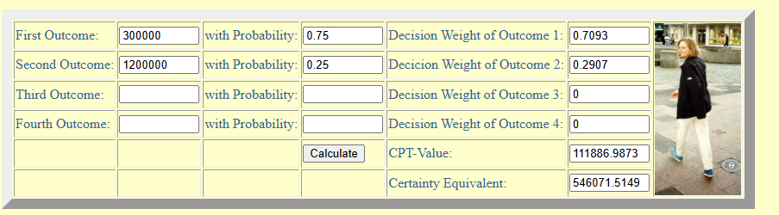

d) Parameter Modification & Sensitivity
Under standard expected value calculations, Alternative B is mathematically superior. Surprisingly, the CPT calculator running Kahneman and Tversky's default parameters also favors Alternative B, generating a CPT-Value compared to Alternative A. To simulate a highly risk-averse founder who would take the guaranteed cash (Alt A), the alpha parameter (power for gains) would need to be dialed down, or the probability of hitting the $1.2M target would need to be reduced.

e) Preferred Alternative & Influencing Factors
Under this specific CPT model, Alternative B is the preferred choice. The determining factor here is the mechanics of probability weighting. The human brain notoriously overweights small probabilities. The calculator perfectly illustrates this: the 25% chance of hitting the massive $1.2M payout is artificially inflated. This "lottery ticket" effect completely overpowers standard risk aversion in the domain of gains.

f) Consistency with Expectations
This output is fascinating because it contrasts with the standard trope that founders always take the guaranteed cash. The CPT results prove that if an earn-out payout is sufficiently massive (like the $1.2M upside here), the psychological allure of that outsized win amplified by our tendency to overweight low probabilities can mathematically justify turning down a half-million-dollar sure thing.

Decision Problem 2: Day-Trading Micro E-mini Futures

a) Problem Description & Alternatives
An algorithmic day trader manually managing a position in the futures market. The trade has gone completely against the technical setup, and the position is currently bleeding cash. The trader must decide whether to respect their original stop-loss or move it back to give the trade "room to breathe."
- Alternative A (Cut the Loss): Close the position immediately for a guaranteed, realized loss of -$250.
- Alternative B (Move the Stop): Hold the position. There is an 85% chance the market continues to trend against them, resulting in a devastating -$400 loss, but a 15% chance the market reverts and the trader breaks even ($0).

b) The Reference Point
The reference point is $0, representing the trader's account balance at the start of the trading session.

c) CPT Calculator Evaluation
Alternative A (Cut the Loss):
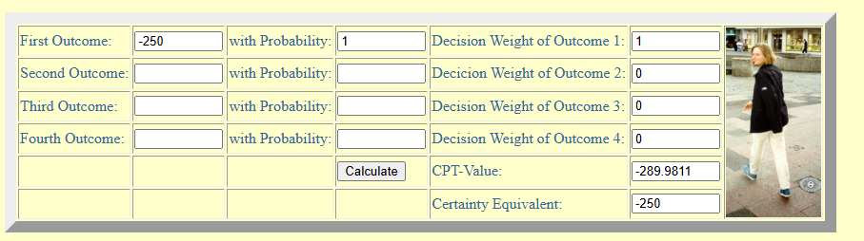

Alternative B (Move the Stop):
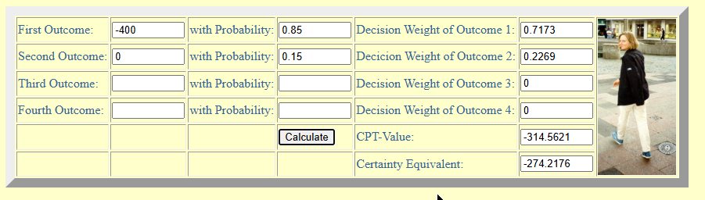

d) Parameter Modification & Sensitivity
Under pure rational Expected Utility, cutting the loss is the obvious choice. The CPT calculator still recommends Alternative A, but the gap between the two choices drastically shrinks. To make the trader actually hold the losing position (Alt B), the loss aversion parameter would need to be dialed up significantly higher than the default 2.25, forcing the psychological pain of the guaranteed -$250 loss to outweigh the risk of the -$400 catastrophe.

e) Preferred Alternative & Influencing Factors
While Alternative A is mathematically preferred, the CPT calculator perfectly maps the psychological trap of Alternative B. Under CPT, the Certainty Equivalent gap collapses to just $24 (-$250 vs. -$274.21). This is entirely driven by the "reflection effect" and probability weighting. The brain overweights the tiny 15% chance of returning to breakeven, bumping its Decision Weight up to 0.2269.

f) Consistency with Expectations
This output is highly consistent with my expectations and explains exactly why retail traders blow up their accounts. Rational logic dictates taking the $250 loss, but CPT flawlessly visualizes the psychological friction. By mathematically proving that our brains artificially inflate the 15% chance of a bailout (closing the perceived gap between a smart loss and a reckless gamble), CPT provides the exact behavioral blueprint for why strict, automated risk management rules must be hard-coded to override human intuition.

References
Johnson, J. G., & Busemeyer, J. R. (2010). Decision making under risk and uncertainty. Wiley Interdisciplinary Reviews: Cognitive Science, 1(5), 736-749.
Kahneman, D., & Tversky, A. (1979). Prospect theory: An analysis of decision under risk. Econometrica, 47(2), 263-291.
Tversky, A., & Kahneman, D. (1992). Advances in prospect theory: Cumulative representation of uncertainty. Journal of Risk and Uncertainty, 5(4), 297-323.

